**It’s Time for Our Fundraiser!**

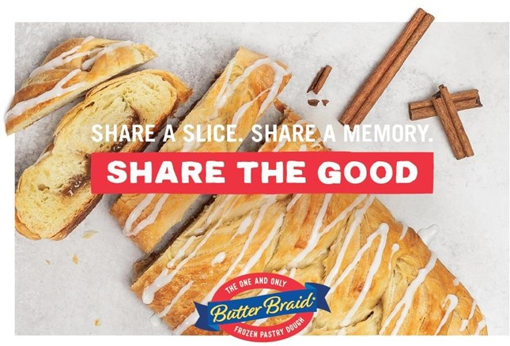

Dear Parents and Participants,

I am very excited to share that we’ve partnered with Freckled Moose Fundraising to raise funds for our group this year! For our upcoming event, we will be selling the delicious Butter Braid® Pastries. Please visit www.freckledmoose.com for more information about the pastries.

Our fundraiser will begin on **«StartOn»**. Order forms were passed out to take orders from family and friends. There is also an online store that is available. Friends and family can order items online. You will receive a link for our organization’s online store or you will receive a link to register for the online store.

Each participant should sell at least **«MinimumPerSeller»** items to ensure we reach our goal.

|  |  |  |  |  |
| --- | --- | --- | --- | --- |
| Return order  forms by: | **«ReturnOrderOn»** |  | Fundraiser  purpose: | «**FundsFor**» |
| Make checks  payable to: | «**MakeChecksTo**» |  | Delivery  date: | **«DeliveryOn»** |

When these items are delivered, they will be frozen. It is important they stay frozen until it is time to bake. Orders placed online must still be personally delivered by the sellers since these products cannot be shipped.

Please contact me with any questions you may have. Thank you for doing your part to make this fundraiser a success!

Sincerely,

www.freckledmoose.com

info@freckledmoose.com